HMS Instructional Model 2016-17/2017-18
For many years, our focus has been on developing students’ critical and creative thinking skills. Although we have made strides toward including this in our instruction, we believe that we need to provide students with more time and opportunity to practice these skills during class time.

Our focus for 2017-18 continues to be on shifting our instructional model to allow for more student-led instructional time. Teachers and CLTs will be asked to continue making strides toward the model below. When planning lessons, we will ask ourselves, “What will students be reading, writing, thinking about, and/or speaking about during this lesson?” The shift takes the focus off of the teachers and on to the students. The amount of time teachers are leading the learning will shrink down to short mini-lessons, as we dedicate more of the lesson to student work time.

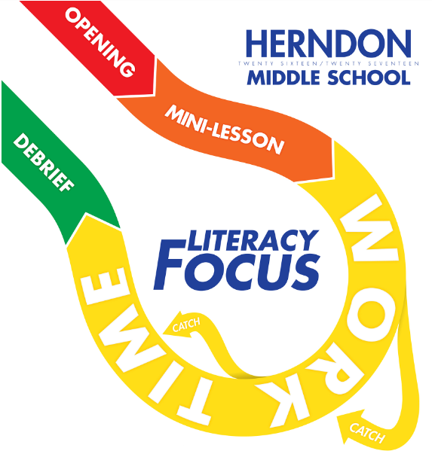

A benefit of this model is that it provides teachers with time during instruction to intervene and meet the needs of all students without relying on Tier 2 and 3 interventions. Teachers will be able to provide targeted instruction to small groups of students during student work time, thus providing immediate feedback and support to students.

We recognize that this change will not occur overnight. This is year 2 on this journey. Now that our staff is familiar with the model and structures are in place for more student engagement, we will begin to measure student learning with assessments aligned to both standards and literacy skills.

